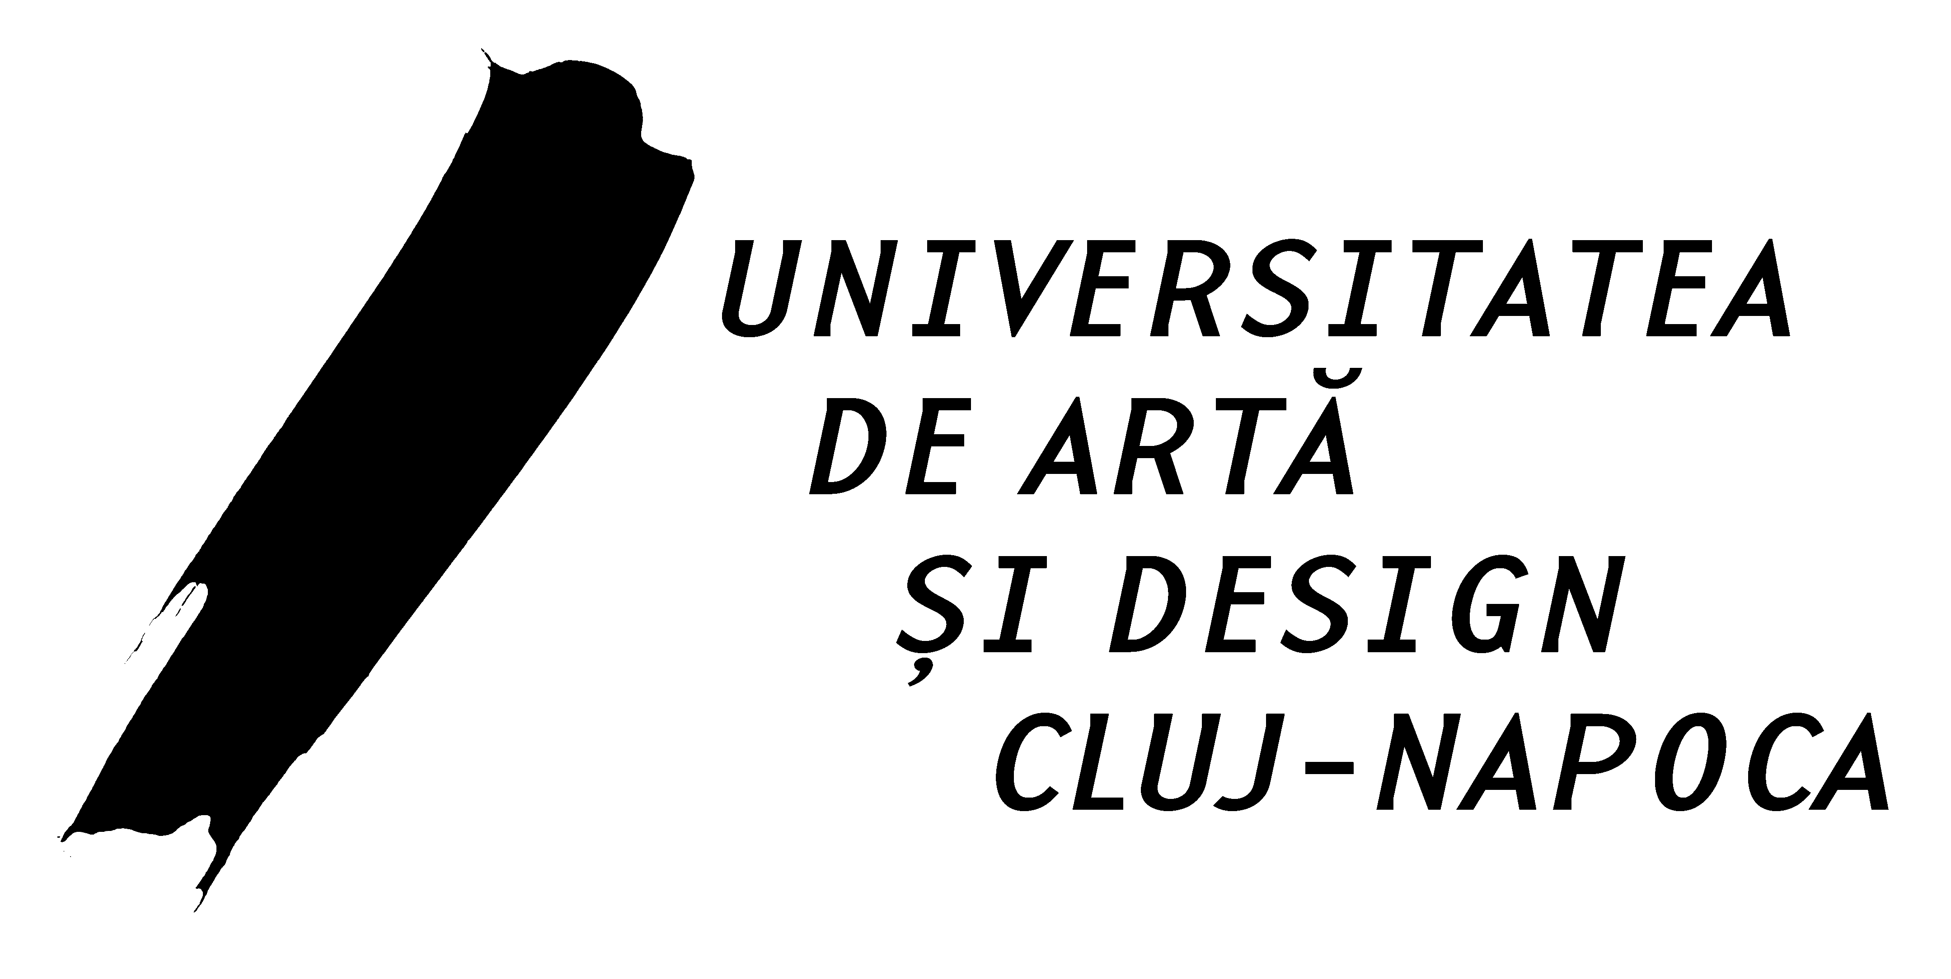
BIROUL ERASMUS+
THE ERASMUS+ OFFICE
Str. Matei Corvin nr. 6
400112. CLUJ-NAPOCA
TEL: +40-264-591477
FAX: +40-264-593386
e-mail: relations@uad.ro


Key Action 1
CERTIFICATE
for prolongation of the student mobility

Name of the Host Institution: | …………………………………………………………  …………………………………………………………  …………………………………………………………
Department | ………………………
Name of the student | ………………………………………………………….
THE DATE TILL WHEN THE PROLONGATION WILL BE DONE | ............................................

Approval of the host institution

Date ………………………. Stamp and signature …………….…………………

Name of the signatory: ……………………………………..
Position: ………………………………………………………….

